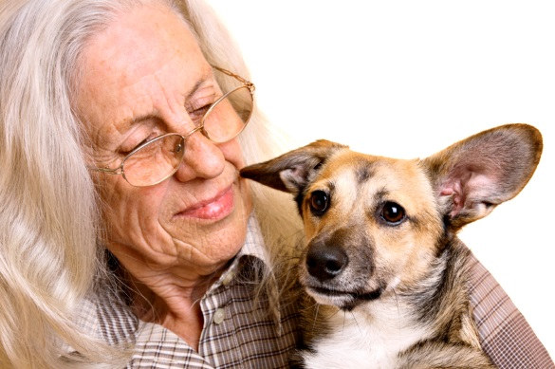

Application for Membership of Pets and Positive Ageing Inc
Mail to info@petsandpositiveageing.com or PO Box 400 CURTIN ACT 2605

MEMBER DETAILS
Please print clearly and in block letters. Associations please also provide incorporation details
Title (Mr/Mrs/Ms/Miss/Dr/Sir) Surname______________________________________ First Name
Incorporated Association Name (if relevant)__________________________________________ Association Registration No
Address
Suburb ______________________________________________________________ State ______________ Postcode
Phone (AH) ___________________ Phone (BH) ___________________Mobile
Email
Age Group (optional) □18-50 □51-64 □65+
To keep you up to date we will forward to you from time to time information of interest to our members. To help reduce our mailing, paper and printing costs we strongly encourage members to receive information via email. This also helps us to help the environment.

In applying for membership you are agreeing to abide by the Rules of Pets and Positive Ageing. The Rules and Objects can be viewed at www.petsandpositiveageing.com.

MEMBERSHIP TYPE

Annual membership is for one year from 1 July. Membership fees are payable before 1 July each year. If you become a Member on or after 1 July, the membership fee is payable within four weeks of becoming a Member. There is no pro-rata membership rate.
□Individual $25 □Pensioners/ Concession card holders $15 □Incorporated Association $50 amily Family Membership $30

PAYMENT METHOD
□ Cash □ Cheque/Money Order (payable to “Pets and Positive Ageing Inc.”) □ BSB 633-000 Account :151653433

Membership | $__________ | Pets and Positive Ageing Inc warmly welcomes donations to assist with our work.
Donation | $__________
TOTAL | $__________
Please note: Membership information is confidential, not for commercial purposes and is collected in accordance with the Commonwealth Privacy Act. Pets and Positive Ageing Inc collects this information for regulatory purposes and to assist with planning and enhancing services to members.

Our website is www.petsandpositiveageing.com

